VPC and Route 53
Create new VPC so its listed under your pvc and enable ipv6:
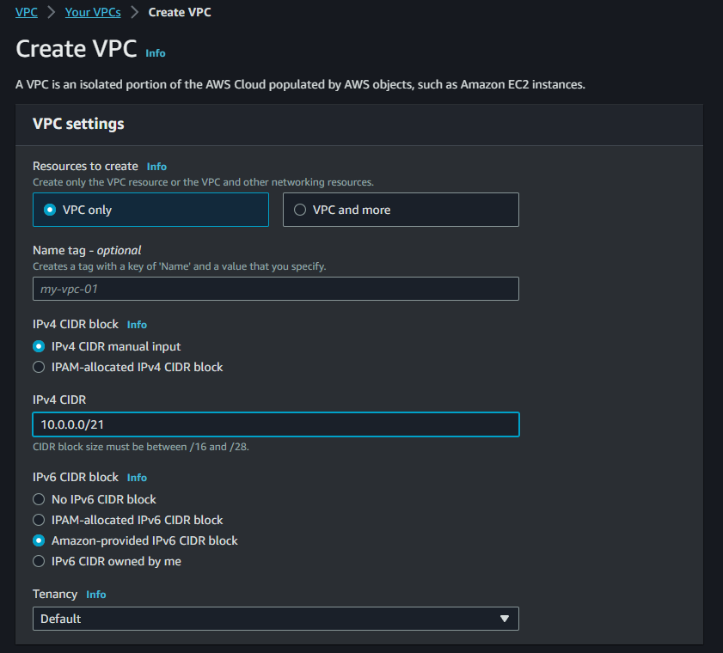
Create 2 subnets one for public and one for private traffic:
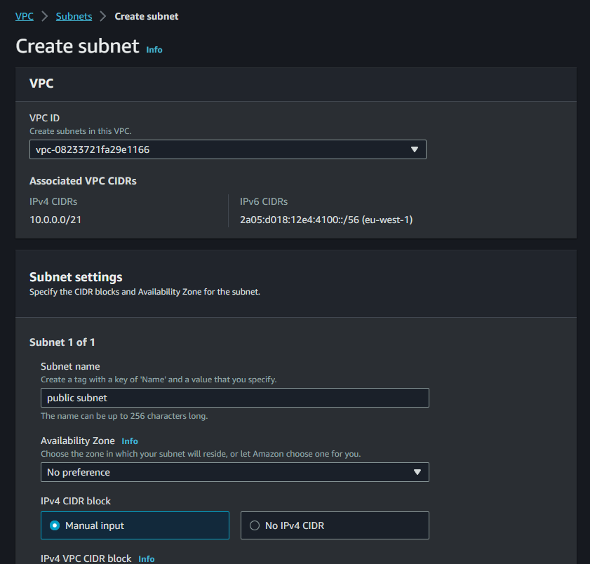
Create a new gateway and attach it to the VPC:
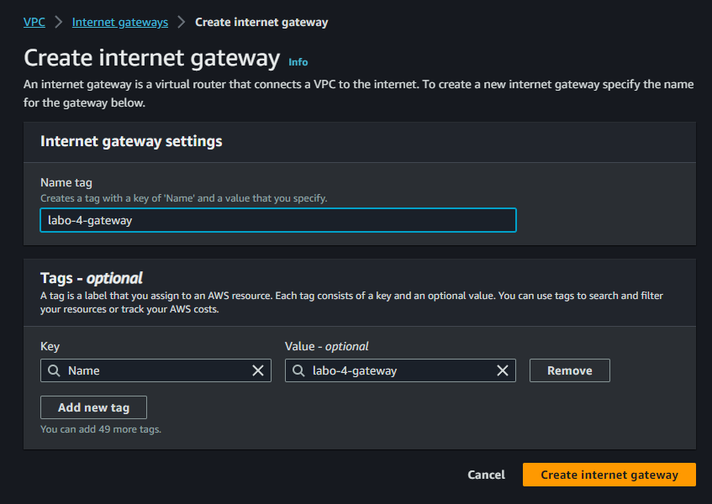
Create 2 routing tables, 1 for public and 1 for private:
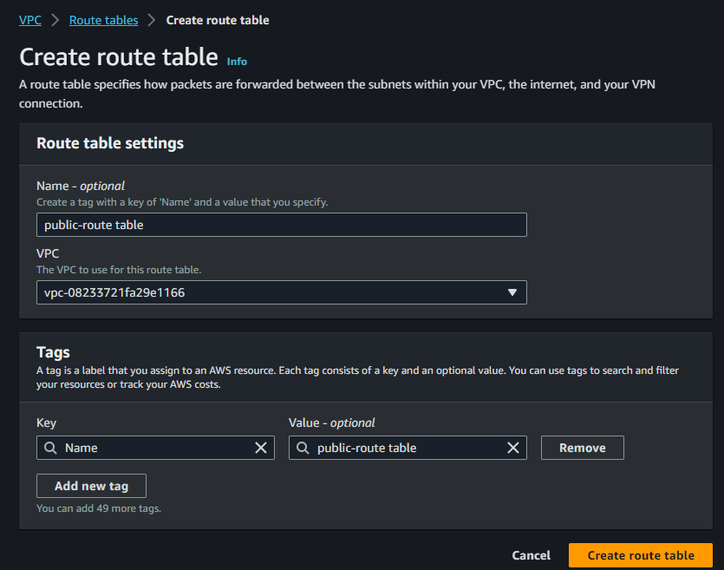
Associate the subnets with the respective routing table:
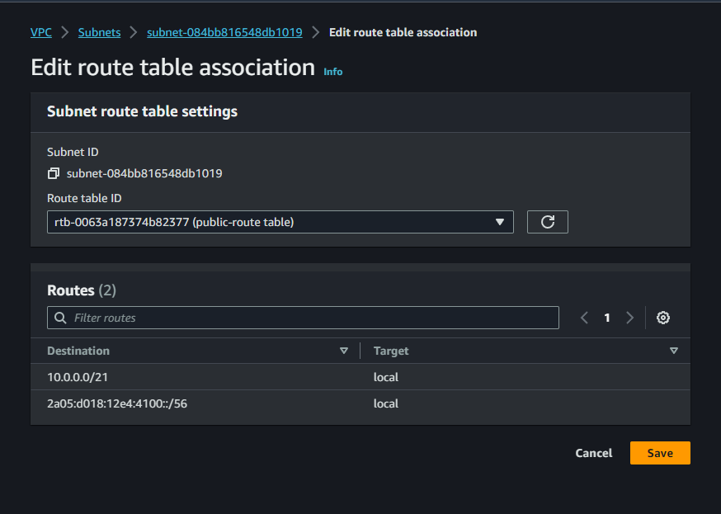
Add gateway to public routing table:
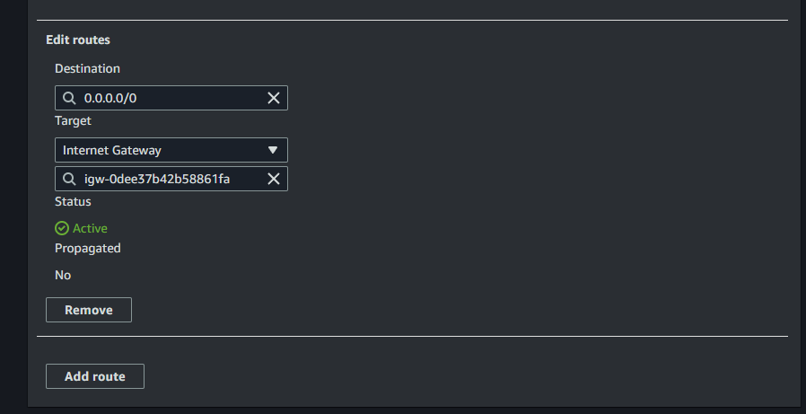
Create 2 EC2 public instances, and one in the private network:
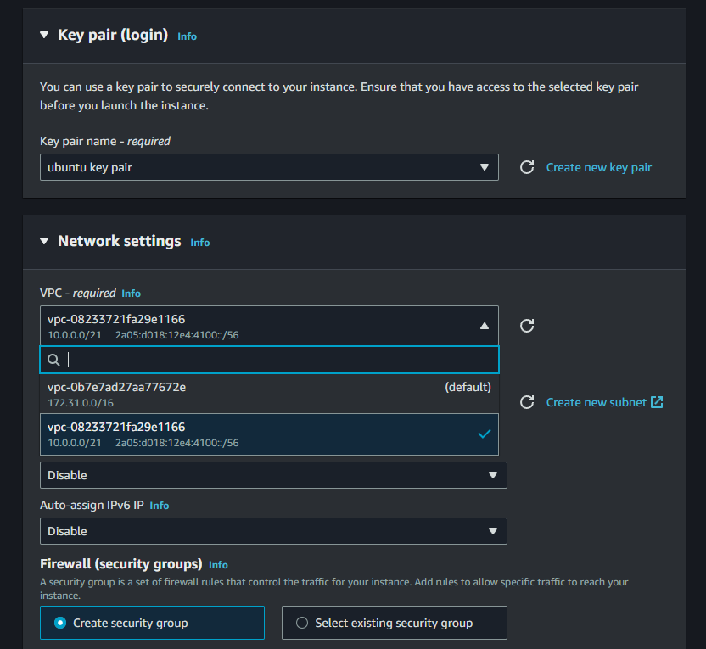
Update and install nginx and php on the public ones.
Create a bastion server that is used to connect to the private server.
Transfer the ssh key over scp.
Create NAT gateway from AWS console, associate with public network and a new elastic IP:
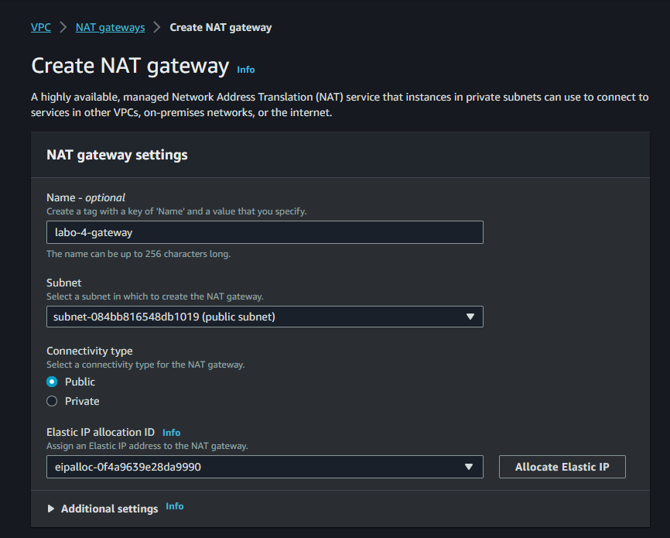
(note: the subnet is connected to where you want traffic to go)
Associate nat with route table with private subnet:
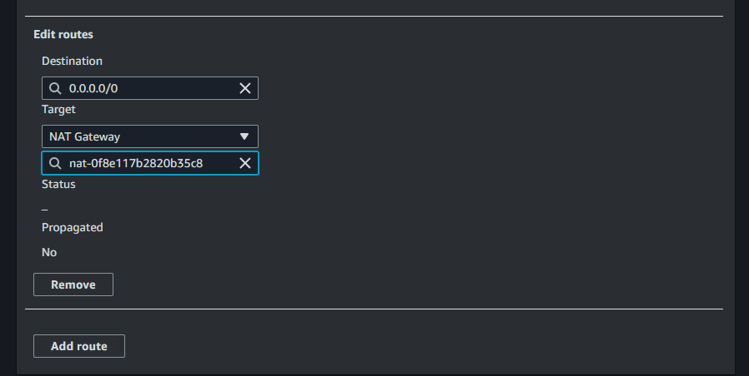
You should have internet now on the private network:
Create a new security group and allow all outbound traffic, while enabling the necessary inbound traffic:
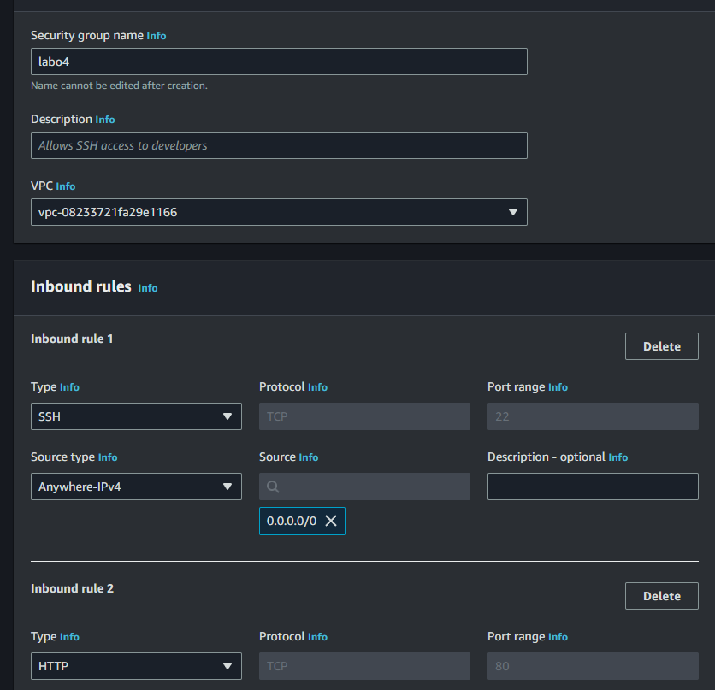Create a new ACL that only allows inbound traffic:
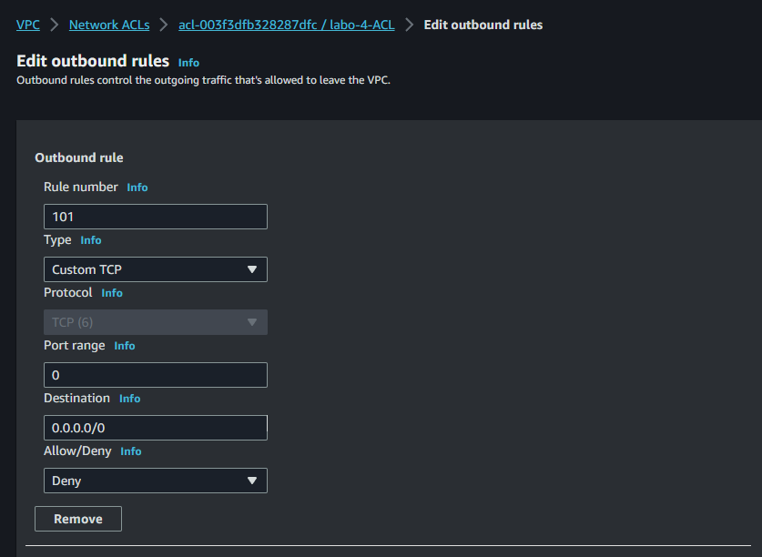
Connect S3 bucket:
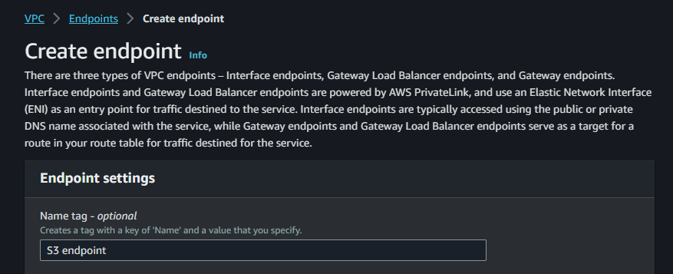
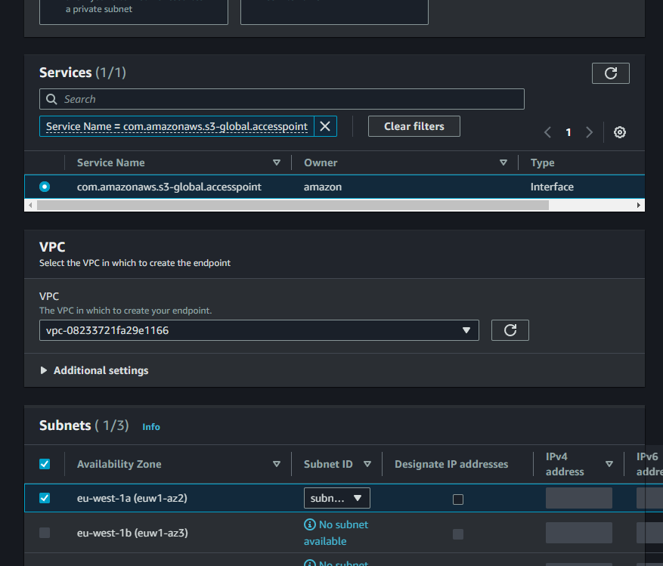
You can now directly access the bucket in the VPC (cheaper then outbound traffic).

Chatgpt on peering connection:
how do i create VPC peering
ChatGPT
Creating VPC peering connections allows you to establish private network communication between two Virtual Private Clouds (VPCs) in AWS. Here are the steps to create a VPC peering connection:
- Prepare Your VPCs: Before creating a VPC peering connection, ensure that the following prerequisites are met:
  - The VPCs must not have overlapping IP address ranges.
  - The VPCs can be in the same AWS region or different regions.
  - Each VPC must have a unique, non-overlapping CIDR block.
  - Make sure there are no conflicting or overlapping route table entries or security group rules that could block traffic between the VPCs.
- Create a VPC Peering Connection:
a. Open the AWS Management Console.
b. Navigate to the VPC service.
c. In the VPC Dashboard, click "Peering Connections" in the left navigation pane.
d. Click the "Create Peering Connection" button.
e. Fill in the required information:
  - Your VPC (the VPC where you want to initiate the peering connection).
  - The other VPC (the VPC you want to peer with).
  - A unique name for the peering connection.
f. Optionally, you can enable or disable DNS resolution and DNS support, depending on your requirements.
g. Review your settings and click "Create Peering Connection."
- Accept the Peering Connection:
After you've created the peering connection, the next step is to accept the connection from the other VPC:
a. In the "Peering Connections" list, select the newly created connection.
b. Click the "Actions" button and choose "Accept Request."
- Update Route Tables:
For the peering connection to work, you need to update the route tables of both VPCs:
a. In the route table of your VPC, add a route that points to the CIDR block of the other VPC through the peering connection. Similarly, do the same in the route table of the other VPC for your VPC's CIDR block.
- Testing and Configuration:
With the VPC peering connection established and routes configured, you should now be able to communicate between instances in the two VPCs as if they were in the same network. You can test connectivity by launching EC2 instances in each VPC and trying to reach resources in the other VPC.
- Security Groups and Network ACLs:
Make sure that the security groups and network ACLs in both VPCs allow the necessary traffic for your applications. Update the rules if needed to allow the specific traffic between the peered VPCs.
Keep in mind that VPC peering connections are not transitive. If you need to connect more than two VPCs, you'll need to create individual peering connections between each pair of VPCs. Additionally, VPC peering doesn't support transitive routing, meaning if VPC A peers with VPC B and VPC B peers with VPC C, VPC A won't have direct access to VPC C; you would need to set up separate peering connections.

